APP (Aluminum Plate Panel) Siding & Soffit MENU ICON
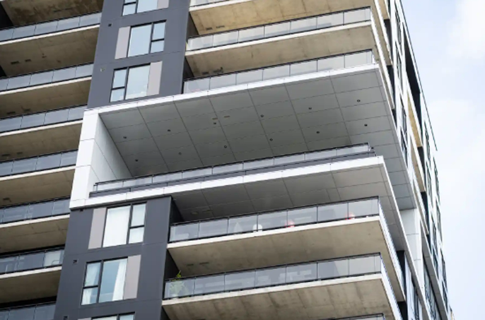
The High-Performance Architectural Aluminum Plate Panels are designed for advanced drained and back ventilated rainscreen systems, this aluminum panel delivers both durability and sophistication..... (Learn More / Expand)

MAIN SUB PAGE
APP (High-Performance Architectural Aluminum Plate Panel) Siding & Soffit
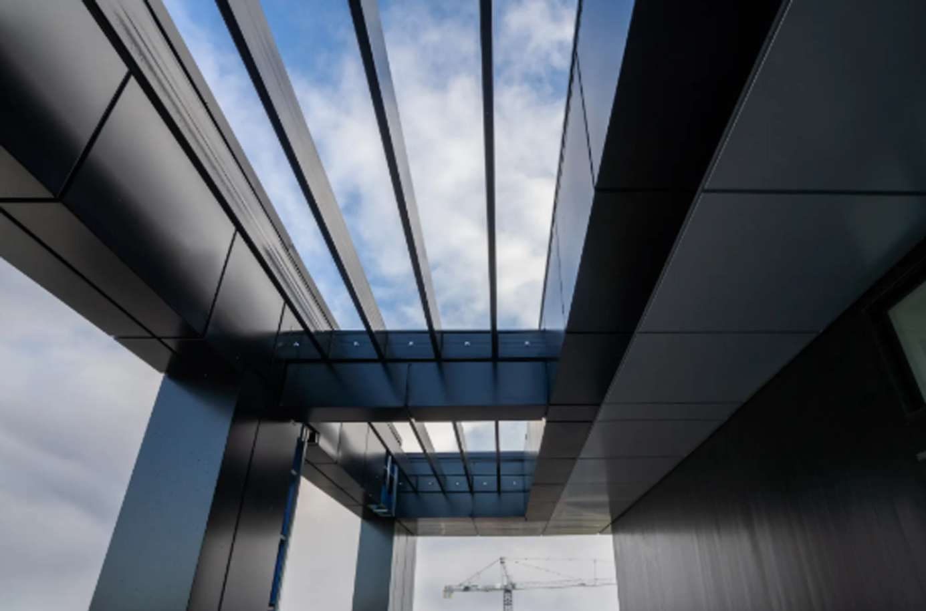
Industrial / Residential / Commercial
Expanded …The High-Performance Architectural Aluminum Plate Panels are designed for advanced drained and back ventilated rainscreen systems, this aluminum panel delivers both durability and sophistication. Crafted from premium 5000-series aluminum with a sturdy 3.2 mm thickness, it offers exceptional strength while maintaining a sleek, modern aesthetic. A concealed fastening system, made from robust 6000-series extruded aluminum, ensures a clean, uninterrupted façade. Ideal for complex architectural projects, this panel is engineered for precision, longevity, and effortless integration into cutting-edge designs.

Key Features
- Thermal expansion brackets for enhanced flexibility.
- Quick and efficient installation.
- Non-combustible, high-performance panels.
- Eco-friendly, solvent-free powder coating ensures long-lasting, fade-resistant colors.
- Highly durable and fully recyclable at the end of its lifespan.

Applications
- Exterior wall cladding for ventilated rainscreen systems.
- Interior decorative paneling for modern design applications.

Speak with an Expert Get personalized advice and expert guidance to achieve your project goals with confidence.

APP Siding & Soffit MENU ICON (PREVIEW)

APP-12 and APP-16 - Cassette-Style Architectural Plank (Board) with Concealed Fasteners
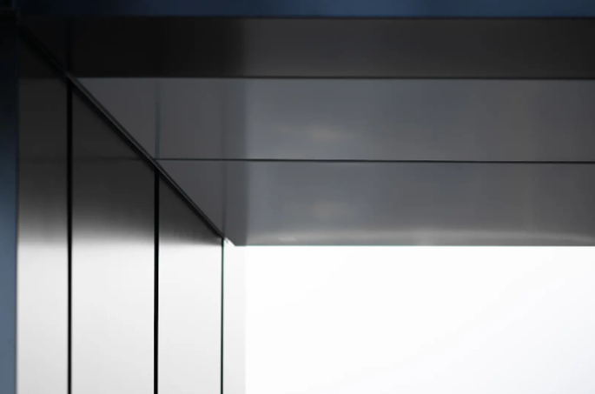
Timeless design meets modern durability. The APP-12 and APP-16 Planks are premium architectural planks made from 2 mm (0.078”) 5000-series aluminum, engineered for exceptional strength and longevity..... (Learn More / Expand)

APP 12 and APP 16 - Cassette-Style Architectural Board (Plank) with Concealed Fasteners (EXPANDED)
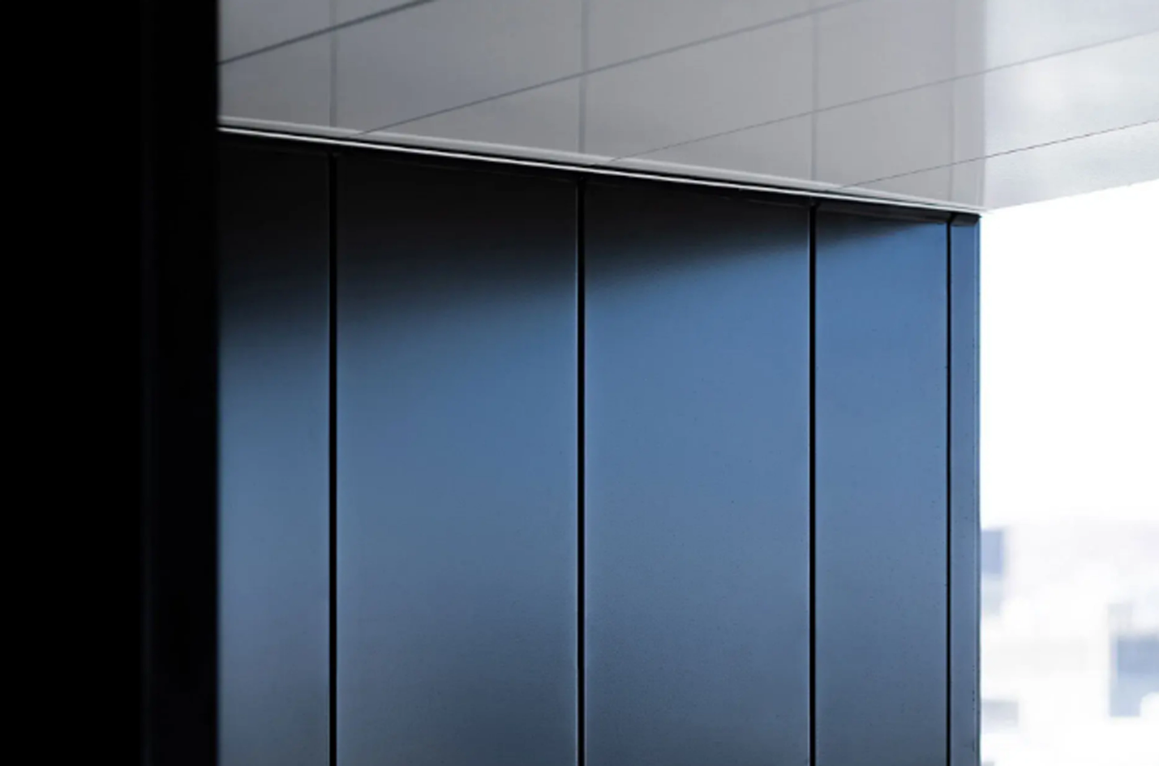
Expanded … Timeless design meets modern durability. The APP-12 and APP-16 are premium architectural planks made from 2 mm (0.078”) 5000-series aluminum, engineered for exceptional strength and longevity. These versatile boards can be installed horizontally or vertically, delivering a clean, linear aesthetic that suits everything from contemporary facades to classic architectural styles.

Each board is precisely folded by advanced robotic systems to ensure uniformity and structural integrity. Where needed, panels are pre-drilled for simplified installation, followed by a high-performance electrostatic powder coating that meets the industry’s toughest standards for durability and colour stability.

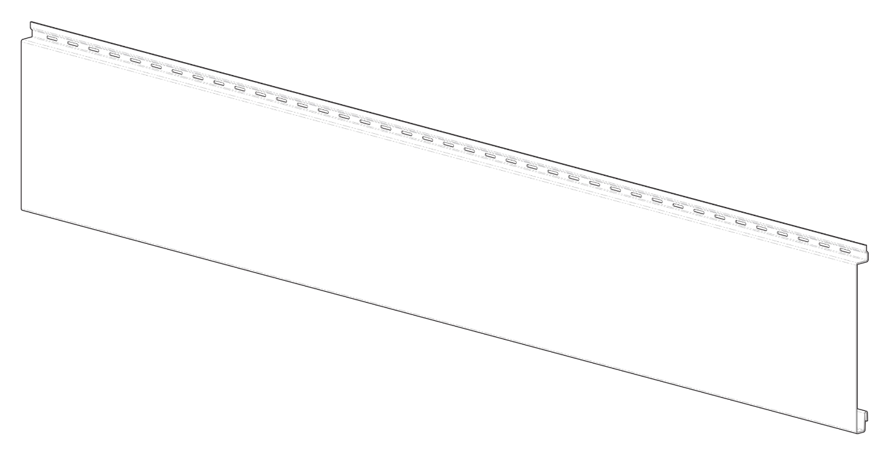
Whether you’re aiming for subtle refinement or bold architectural character, the APP-12 and APP-16 boards offer reliable performance, efficient ventilation, and a design that stands the test of time.

General Specifications
Highlights:
- Fast and flexible installation; can be adjusted or customized on-site
- Non-combustible construction for enhanced fire safety
- Long-lasting, impact-resistant boards that are 100% recyclable
- Finished with a solvent-free, eco-conscious powder coating for superior colour retention and surface resilience

Performance Standards:
- Transverse deflection under service loads limited to L/60
- Axial deflection under service loads limited to L/180

Materials:
- Manufactured from 2 mm (5/64”) thick 5000-series aluminum for excellent strength and corrosion resistance

Finish & Color Options:
- Coated using electrostatic powder application in compliance with AAMA 2604 and 2605 standards
- Fully customizable colour selection to meet any design or branding requirement

Recommended Applications:
- Ideal for interior feature walls or decorative surfaces
- Designed to withstand the elements for use as exterior siding on architectural façades
- **Note: For specific project suitability or custom details, consult with our technical team.

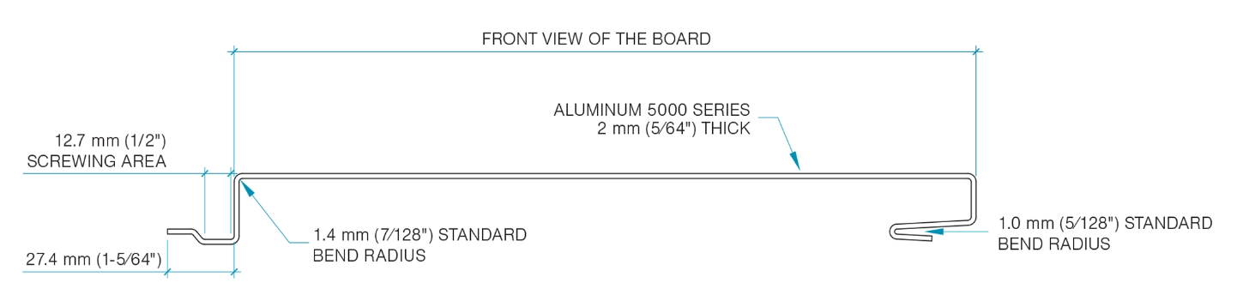
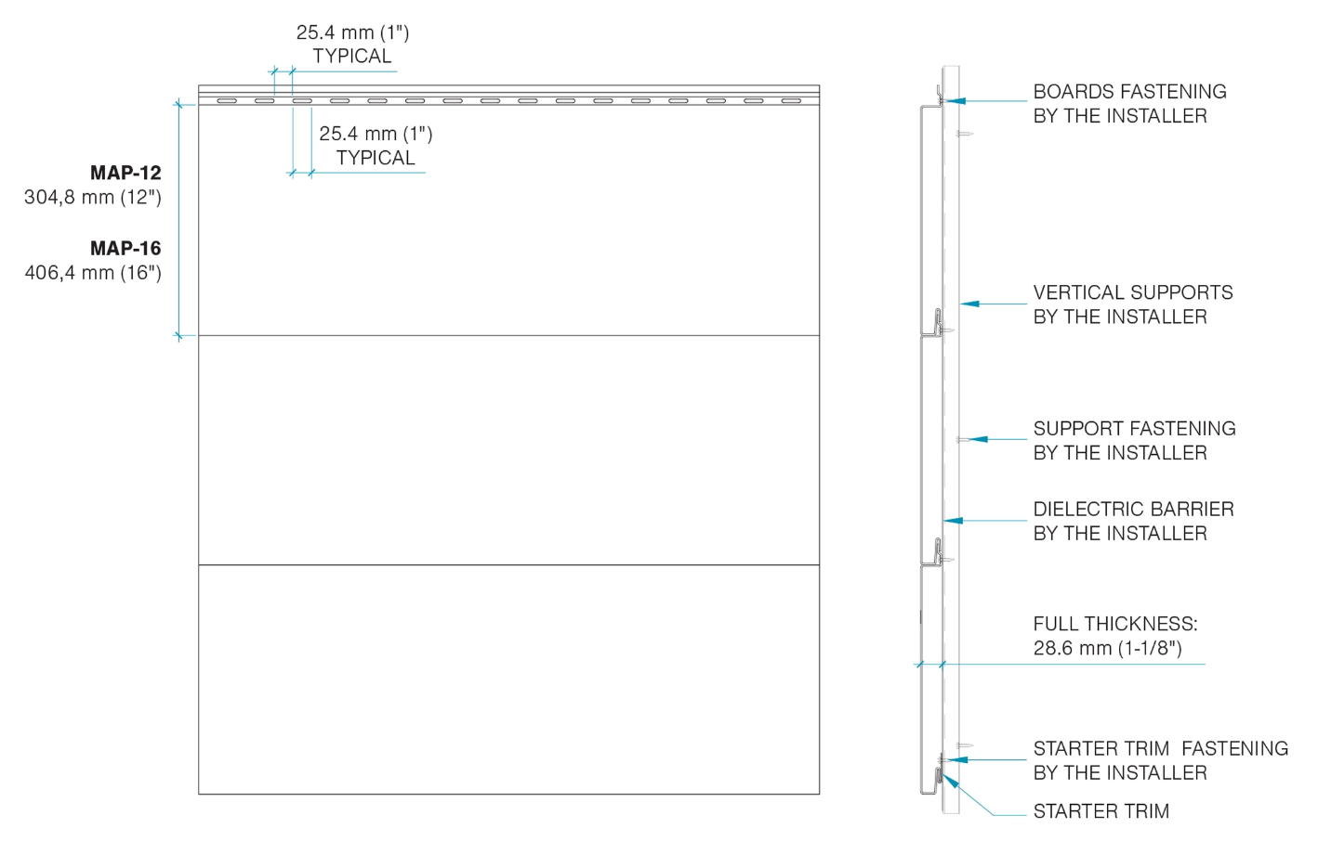

Technical Details
Panel Dimensions:
- APP-12: 304.8 mm (12”)
- APP-16-16: 406.4 mm (16”)

Manufacturing Tolerances:
- Precise fabrication with a lengthwise dimensional accuracy of ±0.127 mm (±1/1064”)

Elevate Your Project with Premium Aluminum Planks

When performance and appearance matter, aluminum panels finished with electrostatic powder coating—meeting AAMA 2604 and 2605 standards—deliver on every front.
At the heart of our aluminum siding line is our custom-built powder coating facility, designed to apply one of the most environmentally friendly and durable finishes available today. This in-house capability ensures consistent quality, rich colour depth, and long-lasting protection against the elements.
Endless Colour Possibilities
From anodized-style finishes to specialty effects and carefully curated palettes, we offer full customization to match your vision. Whether you’re aiming for bold, subtle, or one-of-a-kind textures, our partners can formulate powders tailored precisely to your design goals.

If you can imagine it, we can match it.

